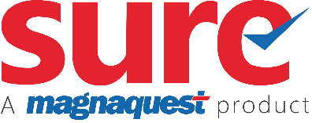
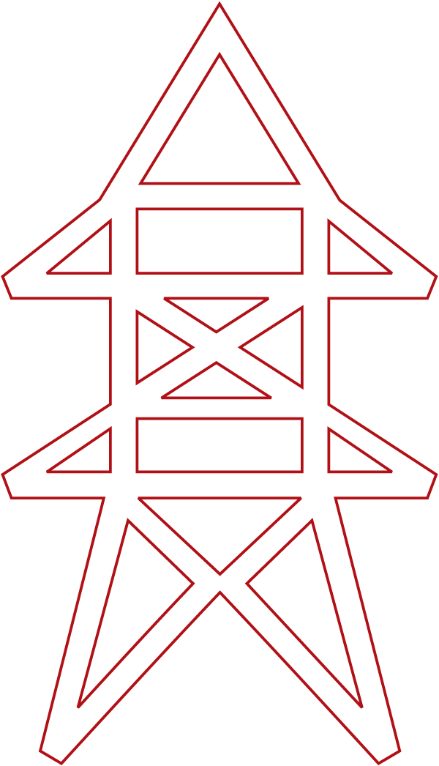
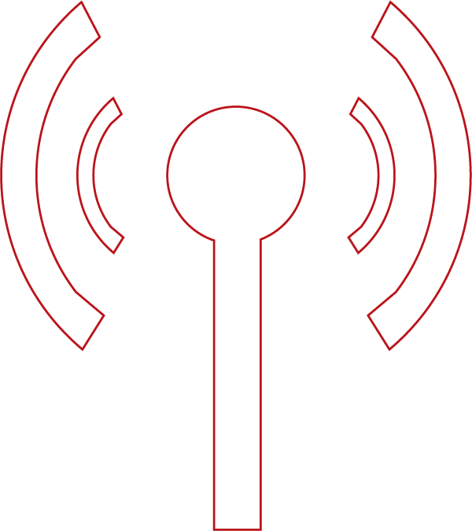


\\\\\\\

Promotions

Contents
About Promotions…………………………………………………………………………………... ………1
Promotion Offerings 1
Free Period 1
Pricing 3
Discounts 3
Free Products 5
Free Upgrade 5
Defining a Promotion Code 6
Defining a Promotion Offerings 9
Free Period 9
Pricing 11
Discounts 14
Free Products 17
Free Upgrade 19
Retrieving of the existing Promotion details 22
Promotion Related Tables 23
Limitations 23
Support………………………………………………………………………………………………… ..………24
Copyright…………………………………………………………………………………………… …………..25

About Promotions
Service Providers as a part of their business marketing strategy announce and offer discounts to their valued customers. These Promotional discounts are applied on selected plans, hardware items, or on the total pay charges that are to be borne by the customers.
By offering these promotional discounts, the Service Providers mainly focus on pulling new customers into their business, retaining the existing customers, sustaining their existence in the market, and grabbing the customer’s attention and satisfaction.
These Promotions are defined along with the price plan in the system. Generally, the Service provider offers these promotional discounts on plans/products for a certain duration of time to the customers. The promotional offerings that are announced by the Service provider are applied only when the customer chooses the corresponding offered plans within the defined offered period.
This document gives a detailed explanation of the Promotional Offerings and how these Promotional offerings are defined and used in the system.

Promotion Offerings
Promotion Offerings are different types of promotions that are offered to the Customers.
The following are the various promotional offerings available in the System:

- Free Period
- Promotional Pricing
- Discount
- Free Products
- Free Upgrade

Free Period
The Free period is one of the wider promotional offerings that are offered to the Customers, where the Service provider offers free service to the Subscribers for a certain duration of time, provided the Subscriber agrees to stay and subscribe to a plan for a committed period.
Here in this free period, the subscription that the Subscriber gets is not charged with any additional money.
The Subscriber charges the money only for the plan’s contract term (E.g. 6 Months, 1 Year, etc.). The rest additional service in the free period is considered as free and is not charged to the Customers.
The services offered in the free period are given as a 100% discount to the Subscribers either in Days/Months.
Example:
On the Subscription of the South-pack plan for the contract term of 1 year, the Subscribers will get one month extra as a Free Period.

Free Period terms
The Free Period promotions are offered to the Customers on certain terms. Following are the terms upon which the Free Period promotions are applied:
Here the terms are nothing but the time period of the contract term in which the Free Period is applicable.
Note: The following terms are explained considering the Free Period duration as 2 Months and the Contract Period as 1 Year (January 1st to December 31st).

- Beginning of the term: Here the Free Period promotion is applied in the initial terms of the Plan’s subscription.
In this case, the Subscriber gets the free subscription in the months of January and February.
- End of the term: Here the promotion is applied at the end of the Plan’s subscription.
In this case, the Subscriber gets the free subscription in the months of November and December.
- After the contract term: Here the Subscriber gets an additional two months of service as a free period.
In this case, the Subscriber gets the free subscription after his contract term. I.e. After the December month, so it would be in the months of January and February of next year.
- Specific terms: Here, in this case, the Service Provider can offer promotions randomly in any particular month(s) or from a particular month to the Subscribers.
For example, for a one-year contract term, the free period can be given on the 6th month of the term. A 100% discount will be given in the 6th month .

Pricing
For subscription-based promotions, the products can be offered for a discounted price than the normal price as a part of a promotion. If the Plans have discounted prices, then the newly discounted prices will be applied to the respective product(s).
Note:
- Before defining the promotional price for a Plan in the Promotion screen, the plan should be defined in the system with respective Charges, Pricing, and Discounts (if any) in the Pricing Screen.
- For Perpetual plans, the discounted price (Promotion Pricing) is continued, and for the Fixed-term plans, the discounted price continues till the end of the Plan’s Subscription i.e. Plan’s contract term.
- If there are multiple services in a plan and if you wish to define the promotional pricing to each service separately, then you can do the same with the promotional attributes like Price Region, Currency, Customer, and Billing Frequency in the Pricing screen.
Example: As a part of the promotional offer, for the new subscribers, the South Pack is given for the discounted price of Rs. 45/- instead of the actual price of Rs. 60/- for the initial one month.

Discounts
The Discounts are another type of promotional offerings to the Customers. In this type of promotion, the offerings are made on the subscription-plans either as a Percentage discount or a Flat discount.
- Percentage: Here the discount is given in percentages. E.g. 20% discount to first-time subscribers, etc.
- Flat: Here the discount is given as a flat amount. E.g. Flat 50 Rupees discount on all the Subscription plans.
Scenario:
If a plan has more than one discount at a time, the System considers only one promotional discount.
Example: If a business has already a 10% discount throughout the year on a certain plan, and in the festival season if the business wants to offer a special promotional discount of 20% on the same plan, then the System considers only one promotional discount at a time I.e. newly defined discount. I.e. 20% discount.

Though there are two discounts on the plan at the same time, the system considers only one discount. Here the 20% discount is applied till the discount period. Once the discount period is elapsed, the previously applicable discount is enforced as per its definition. I.e. 10% discount in this case.

Discount terms
The promotional Discounts are offered to customers on certain terms. Following are the terms upon which the discounts are applied:
Here the terms are nothing but the time period of the contract term in which the Free Period is applicable.
Note: The following terms are explained considering the Free Period duration of 2 Months.
- Beginning of the term: Here the discount promotion is applied in the initial terms of the Plan’s subscription.
In this case, the Subscriber gets the discount in the months of January and February.
- End of within Contract term: Here the discount promotion is applied at the end of the Plan’s subscription.
In this case, the Subscriber gets the discount for the months of November and December.
- Specific terms: Here the discount is applied in particular month
For example, the Customer subscribed to Plan ABC on January 1st, 2019 and the contract validity of the plan is one year, then when the Specific term duration is given as 3 the system considers the discount in the third month of the contract validity year of the Subscription.

Cross Product Discounts
The Cross Product discounts facility is provided for Promotional type Discounts. Here in this functionality, the Service Provider can announce a discount on certain plans, provided the Subscriber has to subscribe/have the other plan as a cross-product.
In other words, the Subscriber will get the discount on a particular plan only when he subscribes to the other mapped plan.
Example: To have a discount on the Disney kids’ product, the Subscriber should have Star Pack as a product subscription.

Free Products
The Free Products offering offers free Add-on products to the Customers on the selected promotional plans for a defined number of months. I.e. with the subscription of a particular plan, the Customer can avail a free subscription to an Add-on product for a defined number of months.
Example: With the subscription of the South-pack plan, the Zee Add-on pack is given as a free product for the first month.

Free Upgrade
In the Free Upgrade offering scenario, the Subscriber’s plan is upgraded to the next higher level as a promotion.
In other words, at the cost of the actual price of the price, the Subscriber is offered the higher-level plan’s service for the defined promotion duration of time.
Example: The Service Provider has defined an SD content Regional Pack for Rs.350/-; Now, when the Subscriber takes this Regional Pack, then based on the plan’s definition, he will be offered with the Upgrade service, i.e. HD Quality Service Channels at the cost of the same Rs.350/- for the months defined in the promotion.

Defining a Promotion Code
To define a promotion, the user needs to create a promotion code and define a validity period for the promotion. The promotion type depends on various Qualifiers such as Operation Type, Billing Frequency, Customer Type, Price Region, Currency, and Operational Entity.
Following are the steps to create a Promotion:
- On Settings, click Order Management, click on Product Catalogue , and then click Promotion.
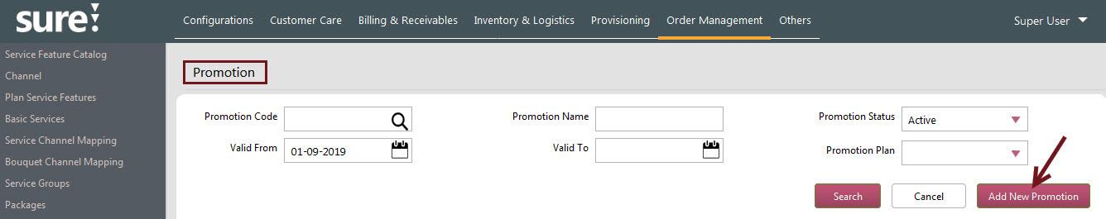
The Promotion screen appears.

- Click Add New Promotion to define a new promotion.
Once the Add New Promotion is clicked, the screen navigates to the Promotion definition screen.
- Enter the code, name, and description for the promotion in the Promotion Code, Promotion Name, and Description boxes respectively.
- From the Status list, select the status as Active to enable the defined Promotion.
Note: Status Inactive disables the promotion code.
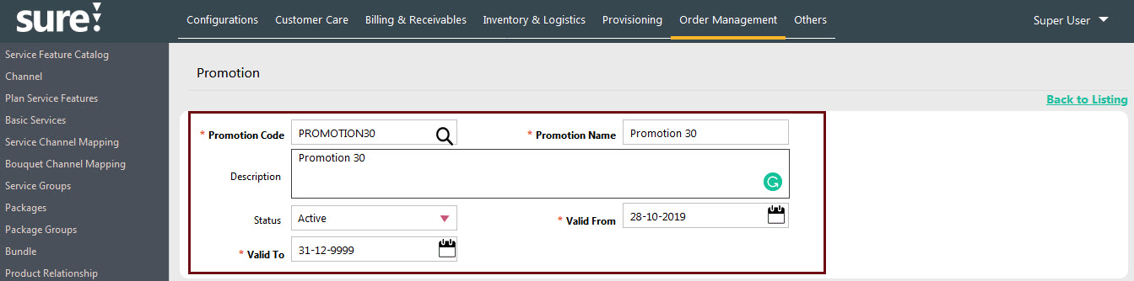
- In the Valid From box, select or type the date from which the promotion should be commenced. In the Valid To box, select or type the promotion end date.

- In the Qualifiers tab, select different qualifiers of the promotion by selecting the check box against the desired qualifier values, Click Save to save the qualifiers selection.
Note: The available qualifiers are Price Region, Customer Status, Operation Type, Payment Method, Billing Frequency, Customer Type, Currency, Operational Entity, and Hardware Item.
You can also use to select the required qualifiers. The Qualifiers selected in the Optional Fields dialog box will appear in the Qualifiers tab.

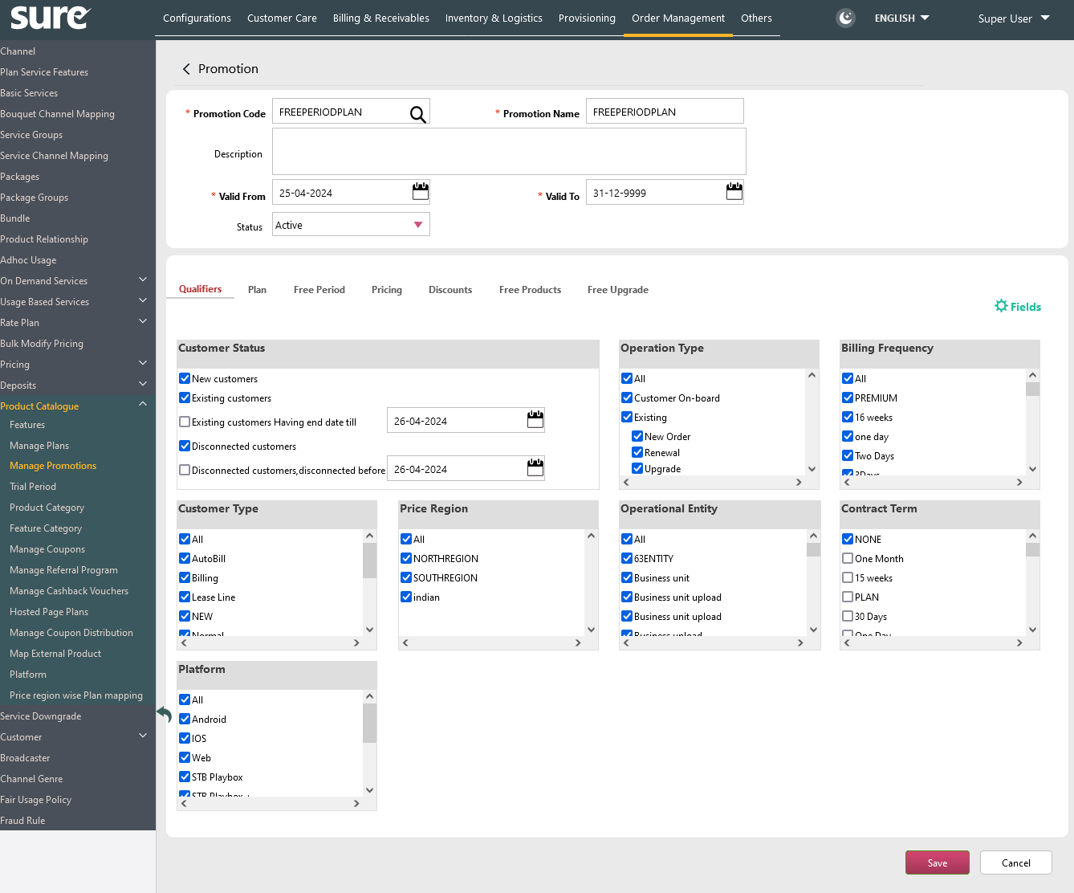

- Once the Qualifiers are saved, click Plan (tab) and Click Add to select the plan for applying the Promotion code to the plan.

- Select the plan details from the Plan list and select the contract term of the plan from the Contract Term list.
To add another set of a row for the plan, click Add.
Note: Make sure, the selected Plan and Contract Term should be already defined in the Pricing screen.
- Once the Plan and Contract term is selected from the list, click Save to save the promotion details.
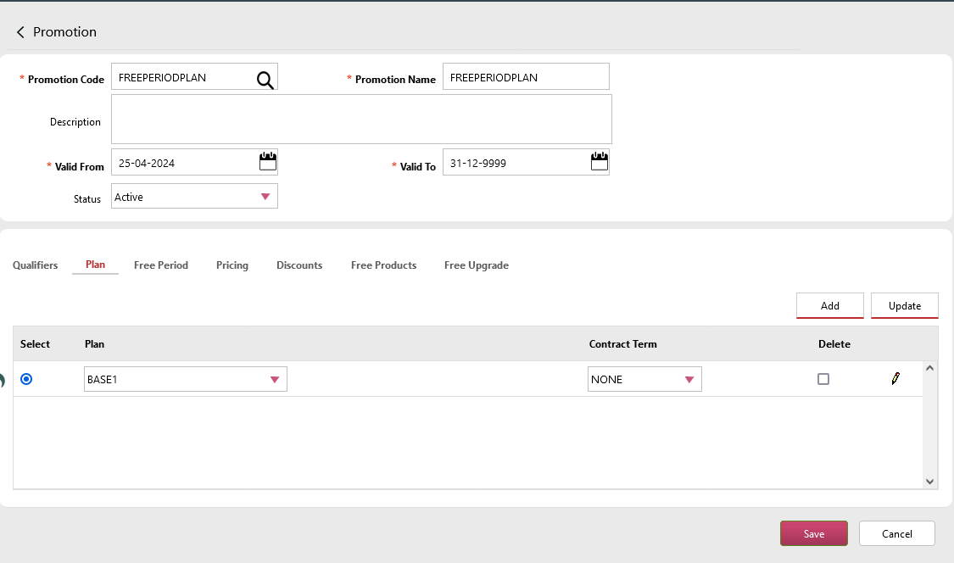

Note: You can select different Offerings to a Promotion by selecting the check box listed in the Offerings section.

The Offerings include Free Period, Pricing, Discounts and Free Products (shown in below screenshot)
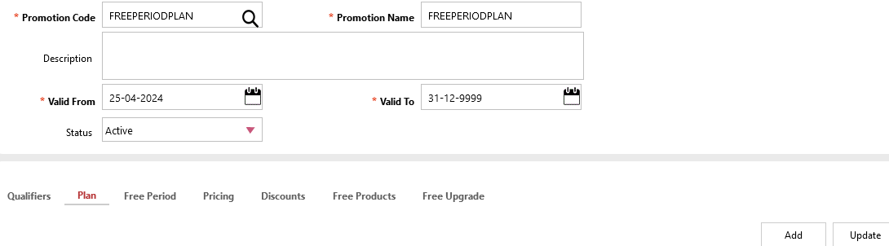

Defining a Promotion Offerings
The Promotional Offerings like Free Period, Pricing, Discounts, Free Products, and Free Upgrade are used to associate different offerings to the selected promotion Plan.
Note:

All the Offerings are Optional. That is, you can select any of these Offerings by selecting the respective check boxes, then that corresponding offering details are listed, from which you can define the offerings to the Plan.
Follow these steps for defining the Free Period Offering to a Promotion.

Free Period
- When the Free Period tab is clicked from the Offerings section, the corresponding options of the Free Period offerings are listed.
Click Edit () to define values for the Free Period
- For the selected plan, define the Free Period values from the options below.
  - From the Discount Code list, select the type of discount.
Notes: All the discount codes defined in the Discount Code screen appear in the list.
  - From the Apply on the list, select the condition value/terms as per your requirement.
The available Free Period terms are:

- Beginning of the term.
- End of within contract term.
- After the contract term.
- Specific term.
Note: Click here for more details on the Free Period terms.
  - From the Terms list, select the duration (Days / Months) for which you want to announce the Free Period. Based on the duration type (Days / Months) enter the value in the box provided against the Terms list.
- Click Save to save the Free Period for a Promotional Plan.

Note:
- You can delete the free period details by selecting the Delete check box.
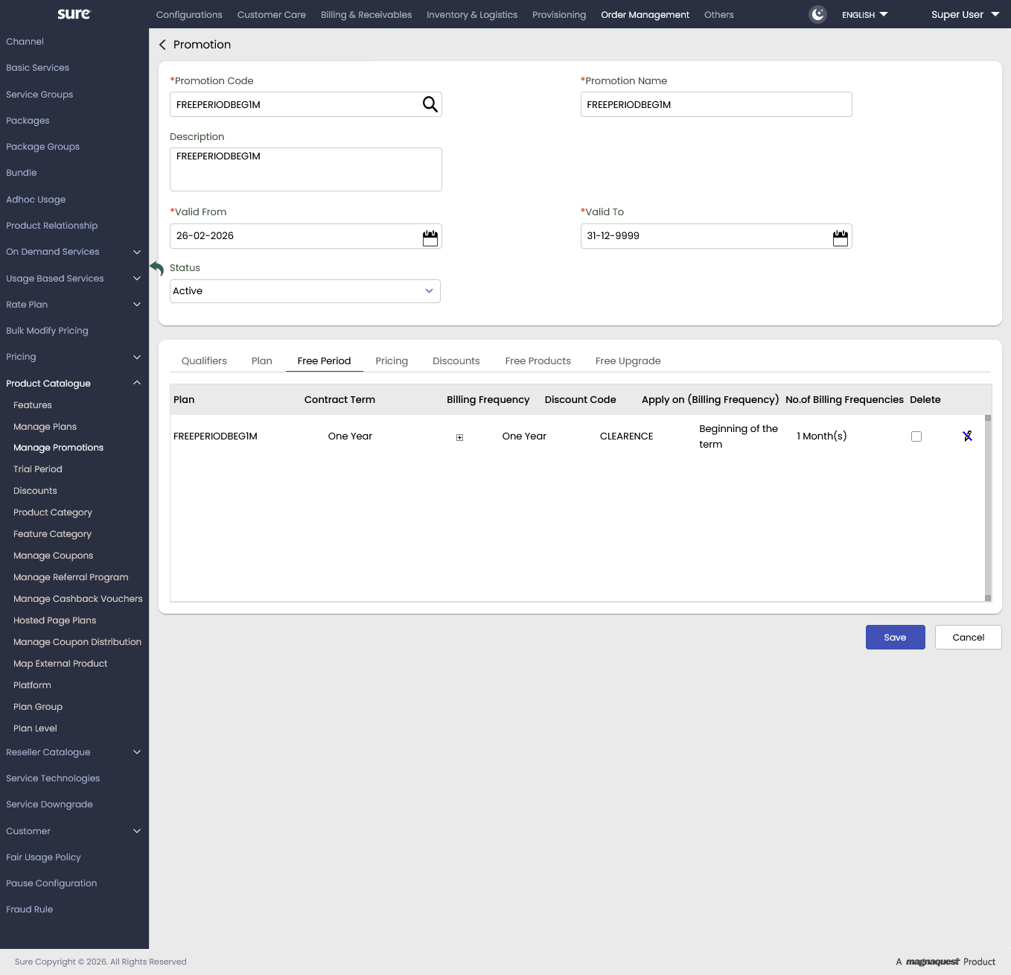
Screenshot 1: Showing Promotion Free Period definition in the Promotion screen

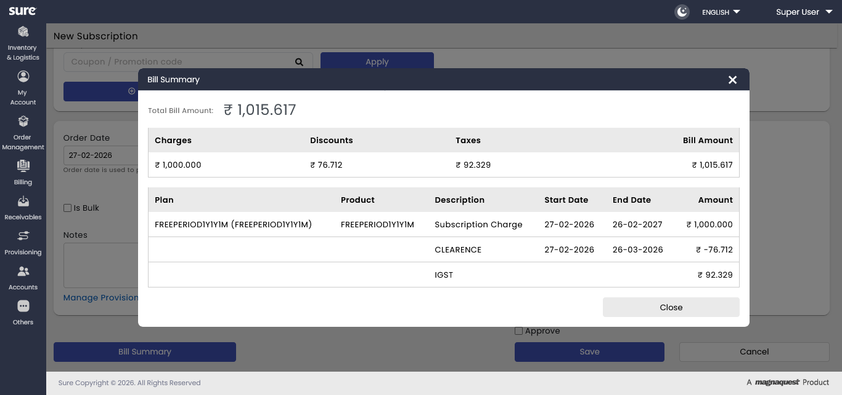 Screenshot 2: Showing the applied Free Period promotion in the Subscriber’s Invoice
Screenshots Inference:

Screenshot 1:

- Promotional Offering: Free Period.
- Promotion Code: PRO_FREE_PERIOD.
- Promotion Name: Promotion Free Period.
In this screenshot example, you can find the promotion Free Period is defined in plan 513PLAN for 1 Month and is applied only for the Beginning of Term.
(The discount code is Happy Sale)
Screenshot 2:

This screenshot is the result of the promotion Free Period. I.e. the promotion Free Period is applied to the subscriber, resulting One-month free subscription to the Subscriber.

Pricing
Follow these steps for defining the Pricing offerings to a Promotion.
- When the Pricing tab is clicked, the corresponding Pricing details of the Promotional plan appear under the Pricing Tab.
Note: All the existing Pricing related details of the plan appear in the table. These values are populated according to the Plan definition that is defined in the Pricing Screen.
If there are multiple services in a plan and if you wish to define the promotional pricing for each service separately, then you can do the same with the promotional attributes like Price Region, Currency, Customer, and Billing Frequency.
- The Plan’s actual price details are shown under the Price column.
To apply the promotional price for the plan, enter the promotional price details in the Promotional Price box.
- To apply any multi-room pricing for the plan, select the Multi Room Pricing check box.
- Click Save to save the promotional pricing details.

Promotional Scheme Instance:
- Click to define a promotional price for the scheme based pricing.
The Pricing Scheme Instance dialog box appears.
- Provide the required promotional details in the dialog box and click Save to save the promotional pricing details for the scheme instance.
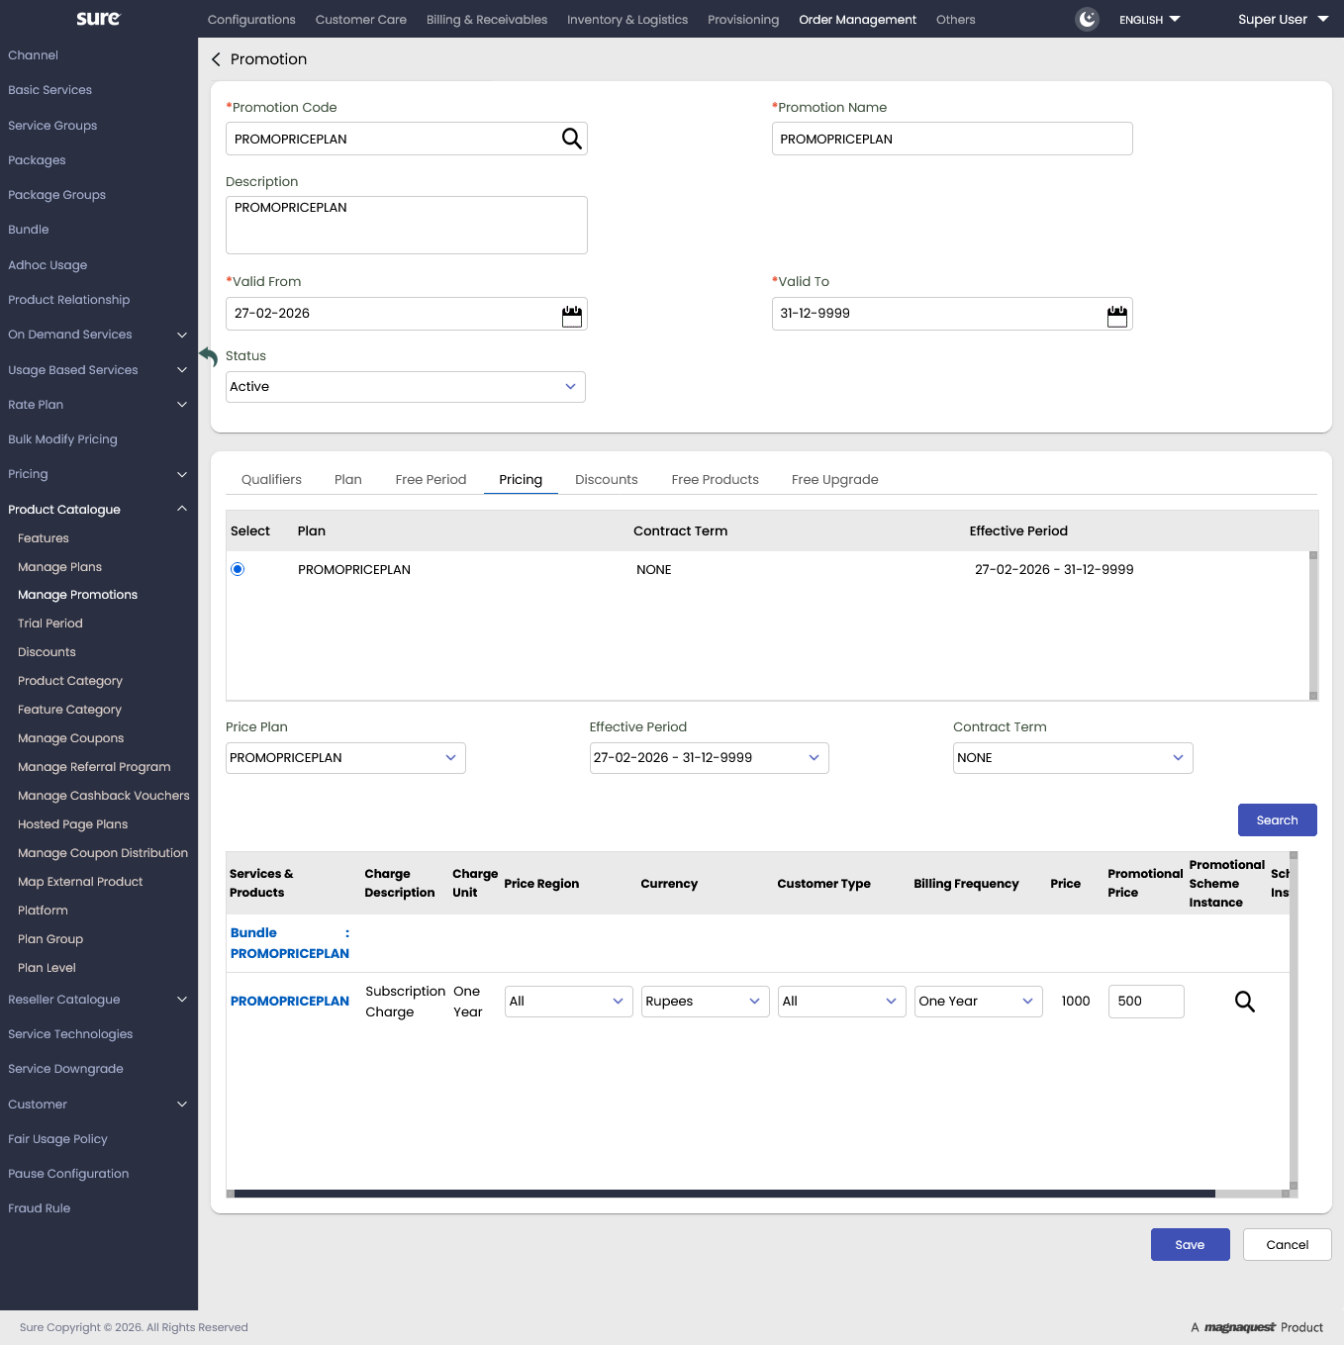Screenshot 1: Showing Promotion Pricing definition in the Promotion screen
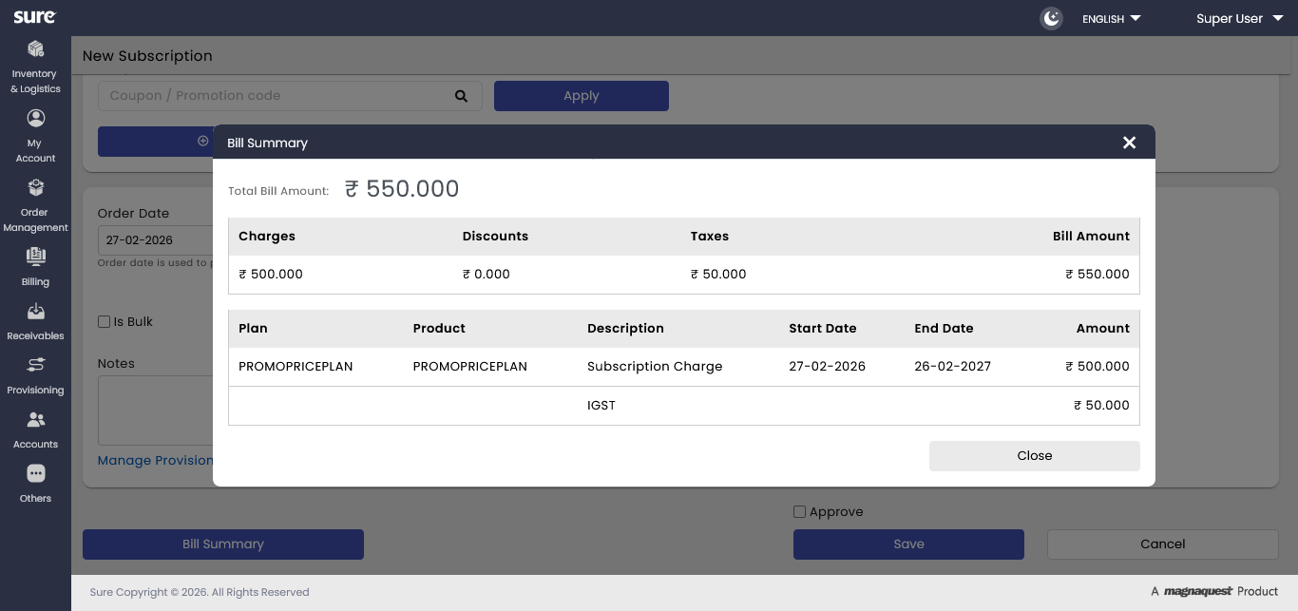
Screenshot 2: Showing the applied Pricing promotion in the Subscriber’s Invoice

Screenshot Inference:

Screenshot 1:

- Promotional Offering: Pricing.
- Promotion Code: PROMOPRICEPLAN
- Promotion Name: PROMOPRICEPLAN.
In this screenshot example, you can find the promotion Pricing is defined on the plan PROMOPRICEPLAN, where the actual price of the Plan Rs.1000/- is reduced by Rs.500/-.
Screenshot 2:
This screenshot is the result of the promotion Pricing. I.e. the promotional price (Rs.10/- off) is applied to the subscriber.

Discounts
Follow these steps to define the Discounts offerings for a Promotion.
- When the Discounts tab is clicked, the corresponding Discount details for the Promotional plan will appear under the Discount Tab.
Note: All the existing Discount related details of the plan will appear automatically in the table. These values are populated according to the Plan definition that is defined in the Pricing Screen.
- From the Apply on list, select the discount’s condition/term as per your requirement.
The available Discount terms are:

- Beginning of the term.
- End of within contract term.
- Specific term.
Note: Click here for more details on the Discount terms.
- Select the discount type as Percentage or Flat from the Discount list for applying the discount Value.
Note: Percentage implies the discount percentage, and the Flat implies the flat amount value that is set as a discount.
Example:
If the discount type is Percentage and the discount value is 10 implies the discount offered is 10% on the base price.
If the discount type is Flat and the discount value is 50 implies Rs.50 is deducted from the base price value.
- Enter the duration value (In Months) in the Duration (Months) box for applying the discount duration.
- Click Save to save the Promotional Discount details.
Note:
You can Add/Remove qualifiers to the promotion Discount by clicking.
All the discount related qualifiers appear in the Optional field dialog box. Select the required items and click Save to display the items.
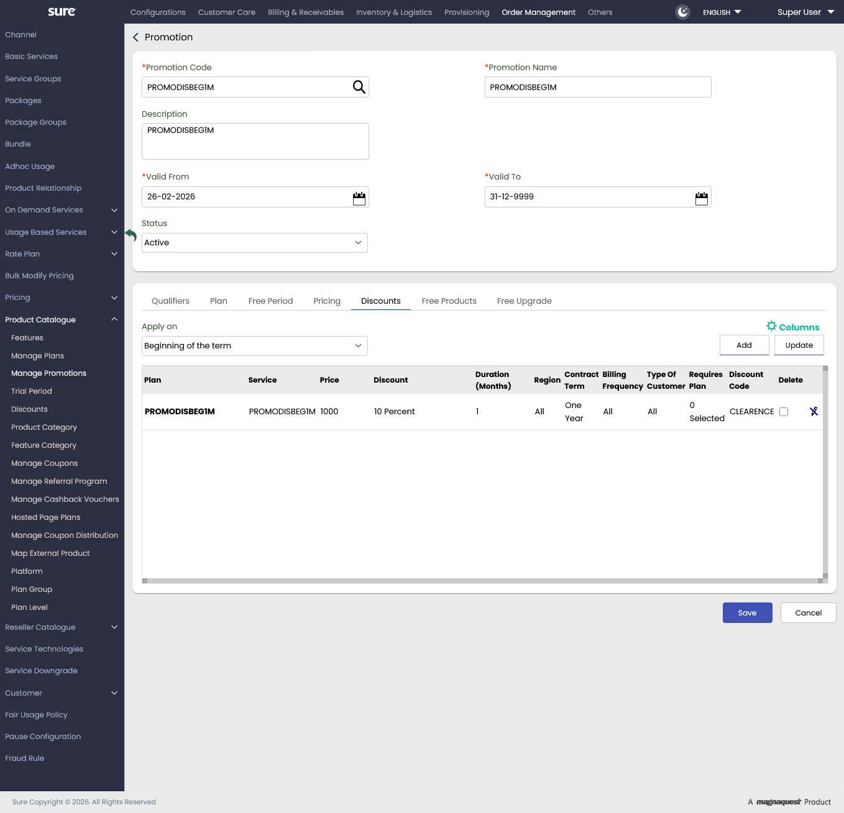Screenshot 1: Showing Promotion Discounts definition in the Promotion screen
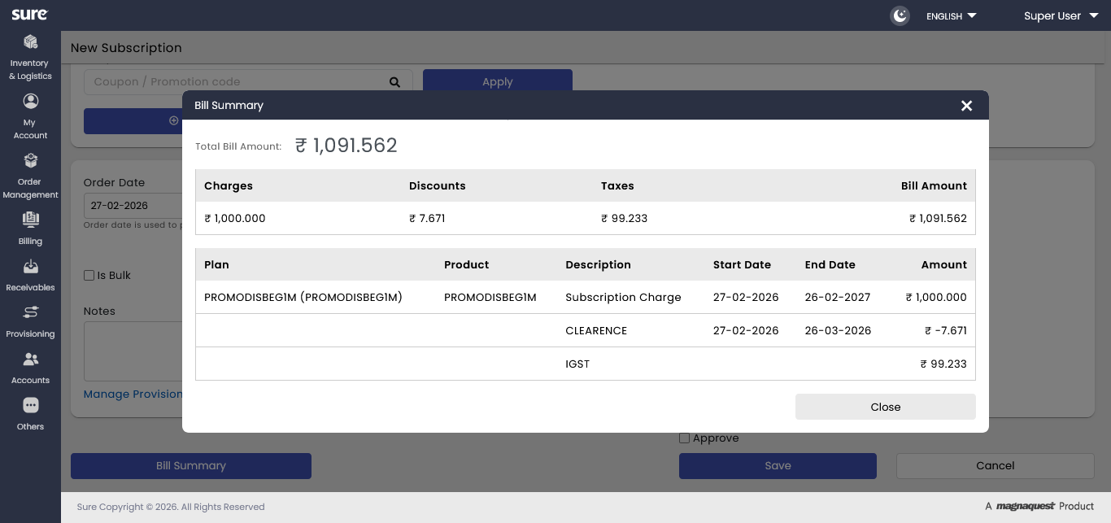
Screenshot 2: Showing the applied Discount promotion in the Subscriber’s Invoice
Screenshot Inference:

Screenshot 1:

- Promotional Offering: Promotion Discount
- Promotion Code: PROMODISBEG1M.
- Promotion Name: PROMODISBEG1M
In this screenshot example, you can find the promotion Discounts is defined on the plan PROMODISBEG1M, where a discount of 10% is applied to the plan for 1 Month.
(The discount code is Clearance Sale)
Screenshot 2:

This screenshot is the result of the promotion Discounts. I.e. the discount of 10% is applied to the PROMODISBEG1M plan Subscriber.

Cross Product Discount Example
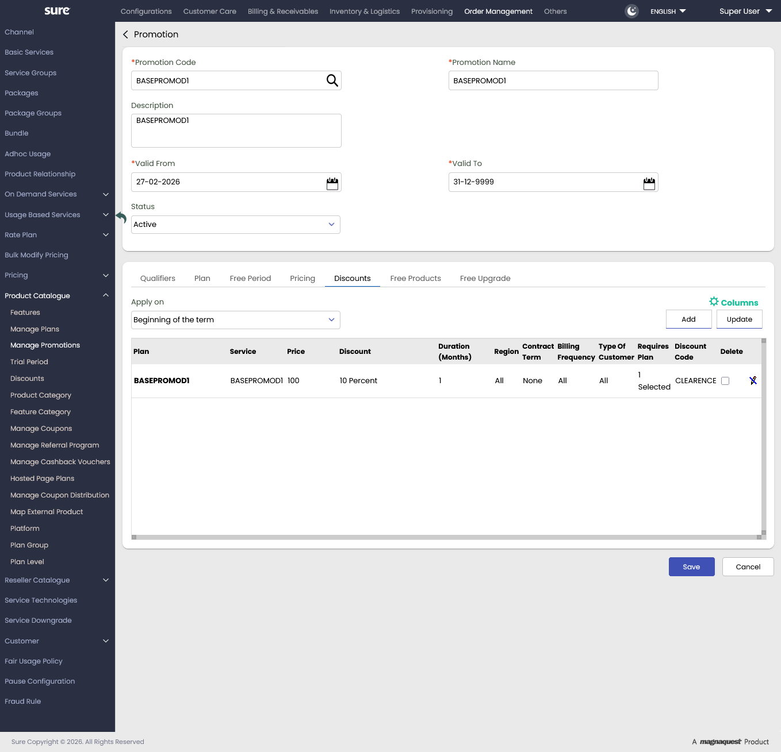
Screenshot is the example for Cross Product Discount
Screenshot Inference:
The above screenshot explains the definition of the Cross Product feature in the Promotional type Discounts. Here, the Applicable Cross Product plan is defined as ADDOND1 for the Subscription plan BASEPROMOD1.
In other words, the Subscriber will get a discount of 10% on BASEPROMOD1 for 1 Month duration when he has plan ADDOND1 as a subscription.
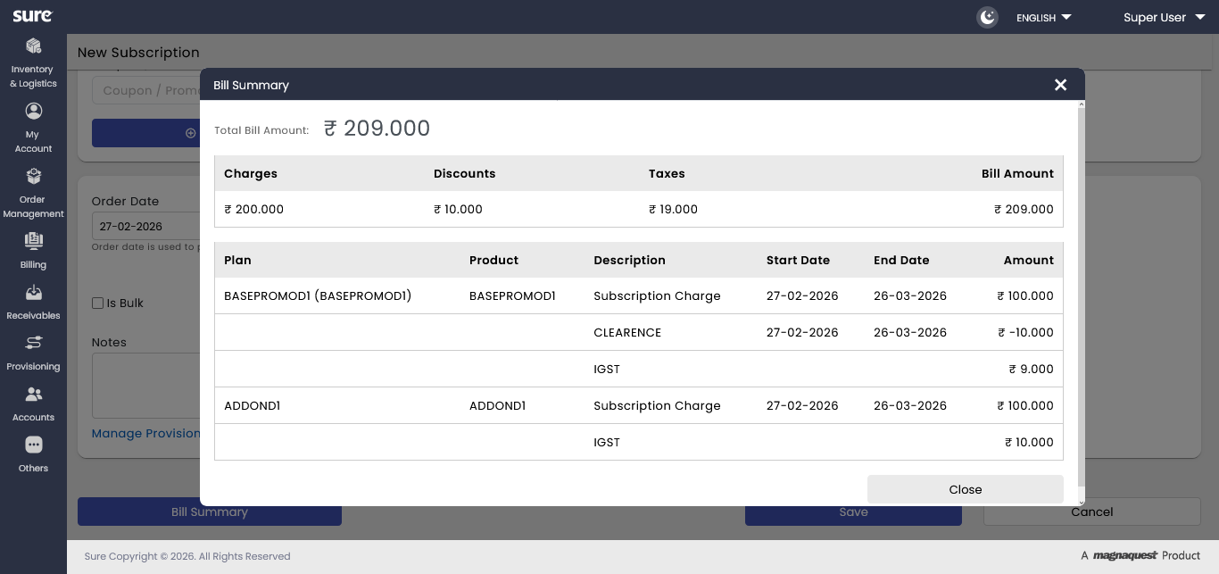
Screenshot Inference:
From the above screenshot we can infer that the Cross Product discount is applied on the BASEPROMOD1, as the Subscriber has taken the plan ADDOND1.

Free Products
Follow these steps for defining the Free Products offerings for a Promotion.
Note: You need to have the Add-on plans for applying the Free Products offering
- When the Free Products tab is clicked, the corresponding Free Products details for the Promotional plan will appear under the Free Products Tab.
- Select the Add-on plan from the Free Products list and select the applicable plans from the Applicable Plans list.
Note: Here, this mapping implies the Subscriber should have the defined applicable plans with him for availing the mapped Add-on plans as free products.
- Select the duration for the free product from the Duration list.
- The Continue After Validity check box has the following behavior
With the selection of the Continue After Validity check box, the Add-on plan will be continued to the Subscriber even after the free period expires.
After the free period expiry, the Add-on plan is treated as a normal subscription plan and will be charged accordingly.
If the check box is cleared /unselected, then the Add-on plan will be disconnected to the subscriber after the free period expiry.
- If required, click Add for adding new rows for the free products definition.
- Once the free product details are defined, click Save to save the details.
- To delete any free product row, select the Delete check box and click Save.
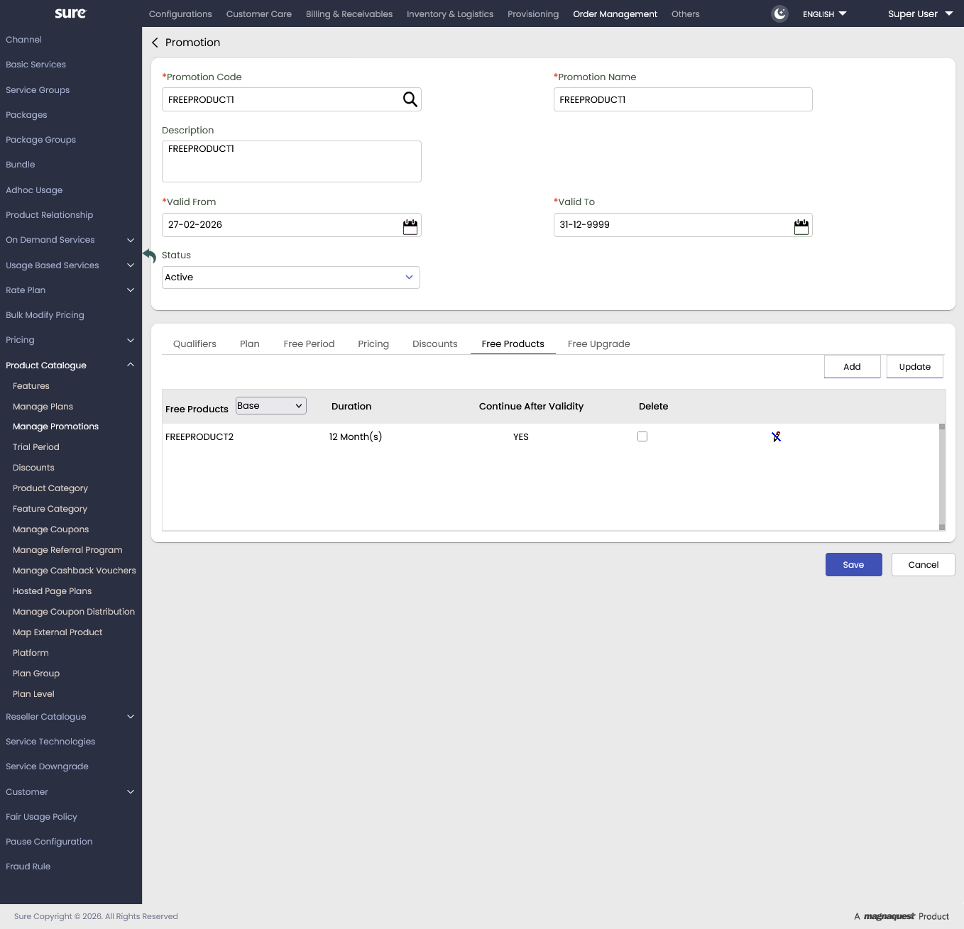
Screenshot Inference:
From the above screenshot, you can infer that FREEPRODUCT12 is defined as a Free Product
Implies, if the Subscriber booked FREEPRODUCT11 he will get FREEPRODUCT11 as Free with zero price

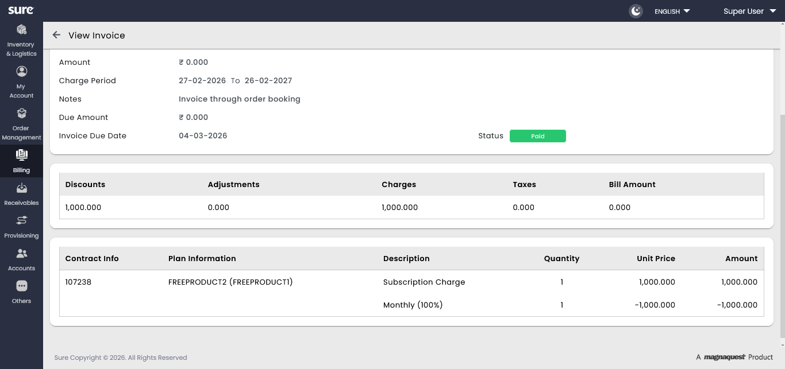Above screenshot showing Invoice of customer got Free plan with zero price

Free Upgrade
Follow these steps for defining the Free Upgrade offerings to a Promotion.
- When the Free Upgrade tab is clicked, the corresponding Free Upgrade details for the Promotional plan will appear under the Free Upgrade Tab.
- From the Plan list, select the plan for which you want to apply the free upgrade.
The corresponding plan details like Contract Term and Service will be listed in the respective lists.
- Select the free upgrade service details from the Upgrade Service list.
This Upgrade Service is the free upgrade that you are offering for the selected plan.
- Select the free upgrade duration from the Duration list.
Here the Duration implies, the time until which the free upgrade promotion is applicable.
- To add more rows, click Add.
- Once the free upgrade details are defined, click Save to save the details.
- To delete any free upgrade row, select the Delete check box and click Save.

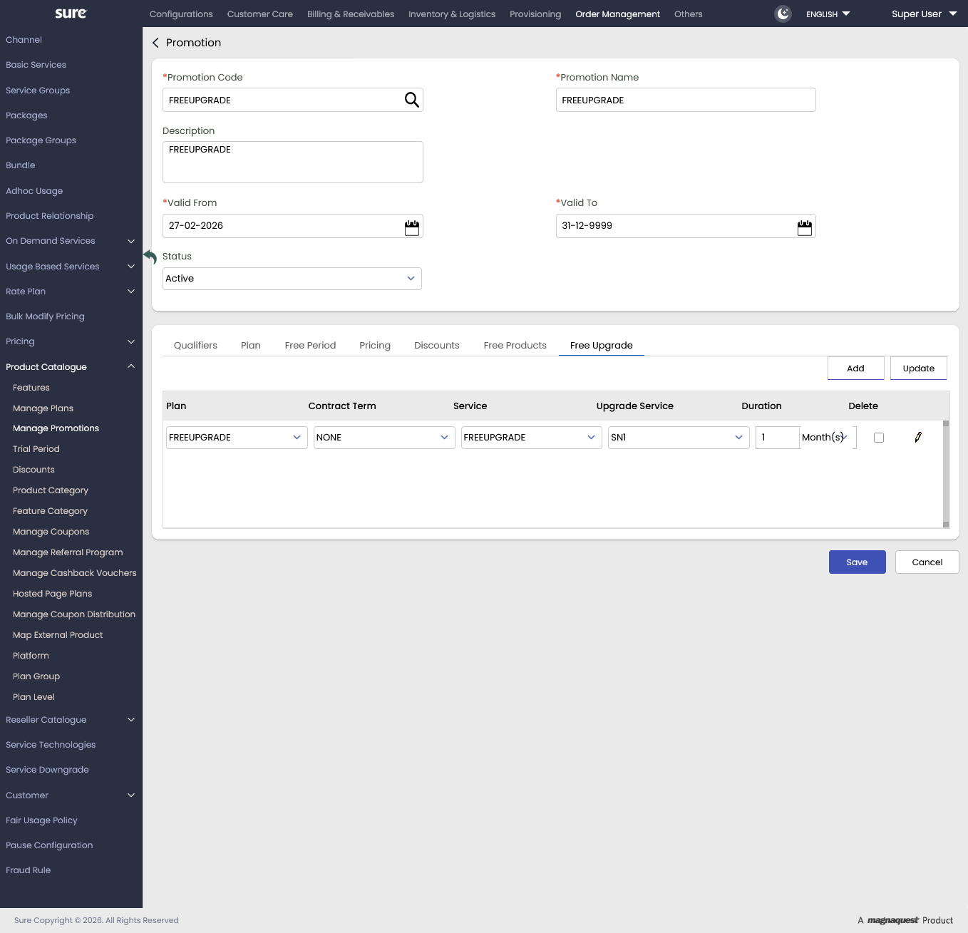
Above screenshot showing Free upgrade plan definition, where when the customer opted for FREEUPGRADE plan he will get upgraded service SN1

Retrieving of the existing Promotion details
Follow these steps to retrieve the existing Promotion Codes.
- In the Promotion Screen, enter the Promotion Code and click Search.
Note: You can also use Promotion Name, Promotion Status, Valid From, Valid To, and Promotion Plan as other search elements for retrieving the promotion code.
- Once the Search button is clicked, the matched Promotion Code details appear below.
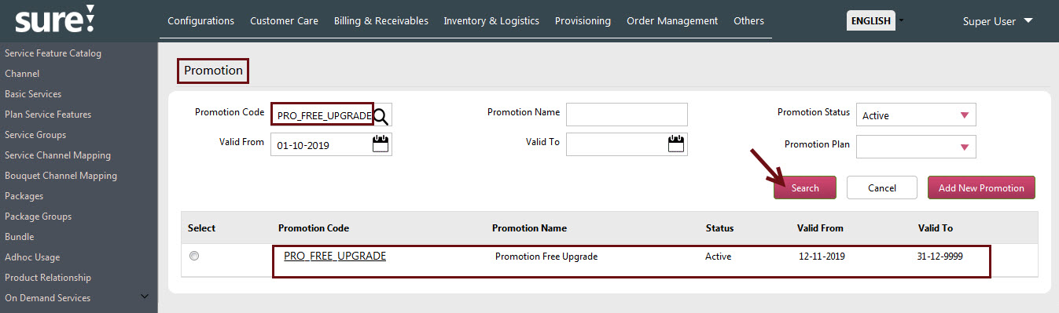
- From the populated Promotion Code details, you can also know the list of offerings that are associated with the Promotional plan by clicking on the Select Option button against the Promotion Code.
The offerings which are associated with Promotion will be highlighted in Green color, and the ones in the Red imply no offering are defined.
You can also directly jump to the Promotional offerings definition by clicking the corresponding offerings link highlighted in the Green.
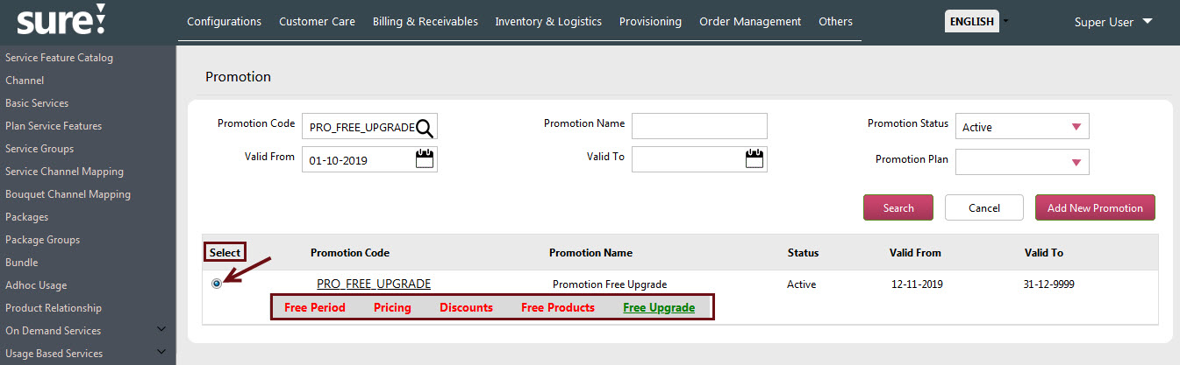

Promotion Related Tables
Following are the Database tables that are related to the Promotions.
- PROMOTION
- PROMOTION_QUALIFIER
- PROMOTION_PLAN
- PLAN_RATE_PROFIILE
- PLAN_RATE_DISCOUNT
- PROMOTION_FP_DISCOUNT
- PROMO_FREE_PRODUCT
- PROMO_FREE_PRODUCTS_DTLS
- PROMOTION_FREE_UPGRADE
- PROMOTION_CROSS_PRODUCT
- PROMOTION_EVENTS
- PROMOTION_PLAN_DISC_CATEGORY

Limitations
The following are the Limitation to be considered for the Promotions.

- The system will not process the order if more than one promotion is applied with the same rules.
.

Support
For further information or any technical support, please contact:
E-mail: mqssupport@magnaquest.com, bcrm.support@magnaquest.com
Phone: +91 9866558383

Copyright

This document is the property of, and is proprietary to Magnaquest Technologies Limited (Magnaquest). It is not to be disclosed in whole or in part without the expressed written authorization of Magnaquest, and shall not be duplicated or used, in whole or in part, and shall be returned to Magnaquest upon request.
Copyright © 2026 Magnaquest Technologies Limited (Magnaquest). All rights reserved. All trademarks, trade names, service marks, and logos referenced herein belong to their respective companies.

